Faculty of Business Administration, Business Informatics and Business Law

Title

Bachelor Thesis / Master Thesis / Seminar Paper

To obtain the degree of Bachelor / Master of Science at the Faculty of Economics, Information Systems and Business Law at the University of Siegen.

Surname, First Name: Mustermann, Max
Address: Mustermann Straße 1
57076 Siegen
E-Mail: max.mustermann@student.uni-siegen.de
Studies: xxx
Matriculation number: 111 111
Semester: xxx
Examiner: Prof. Dr. Giuseppe Strina
Date of submisison:

Executive Summary
Please enclose the Executive Summary behind the cover page. Note, first, that the Executive Summary is not listed in the table of contents, and second, that you use the Standard style for the Executive Summary.

Table of contents
Executive Summary II
Table of contents III
Table directory IV
Table of figures V
List of abbreviations VI
1. Introduction 7
2. Body 8
2.1. Breakdown 1 8
2.1.1. Breakdown 2 8
3. End 9
Bibliography X
Appendix XI
Statutory Declaration XII

Table directory
Table 1 – Plan results of XY GmbH 8

Table of figures
Figure 1 – Example XY 8

List of abbreviations
Please note that common abbreviations such as e.B. do not have to be listed.

AG – Arbeitgeber
AN – Arbeitnehmer

- Introduction
[Continuous text]...

- Body
Graphics & tables please provide with line break: Top and bottom.

[Continuous text] ...
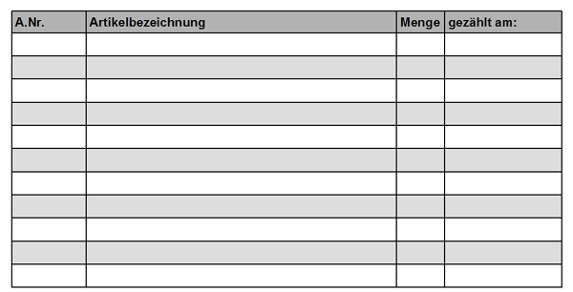
  - Breakdown 1
Table 1 – Plan results of XY GmbH
Source: Own presentation according to...
[Continuous text] ...

    - Breakdown 2
Figure 1 – Example XY
Source: Own presentation according to...
[Continuous text] ...

- End
[Continuous text]...

Bibliography
Please according to APA current edition

Burnham, T. A., Freis, J. K., Mahajan, V. (2003). Consumer Switching Costs: A Typology, Antecedents, & Consequences, 31(2), 109-126.

Appendix
Please number the entries in the attachment. Make sure that figures and tables also appear in the respective directories.

[Continuous text] ...

Statutory Declaration
I hereby assure you that I have written the present work independently and have not used any sources and tools other than those indicated, in particular no other than the information provided on the Internet.
I have taken note of those paragraphs of the examination regulations that apply to me, which concern any attempts at fraud.
I agree to the storage of my seminar paper for the purpose of plagiarism checking. I assure you that the content of the electronic version matches the content of the printed version.
[Location]
[Date]
Signature:

